
Mental Health Monday
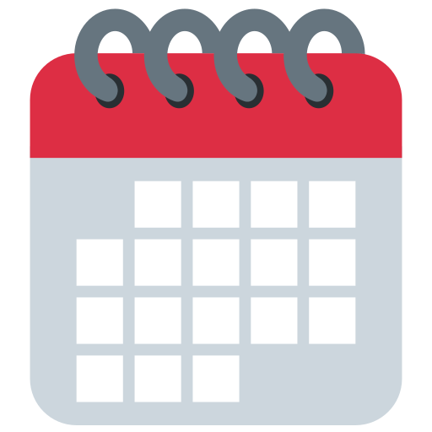
It’s time for your say, let us know what you need. We’re here to help you!
Name:………………………………………………… Date:……………………………………
- Do you feel safe in school (please circle your answer)? Yes No

- This morning I am feeling (please tick your answer)……

- Happy

- Ok, could be better, could be worse
- Not motivated


- Really bad

- Angry
- Anxious/nervous
- Any other feeling?............................................................................................................


- How was your weekend (please tick your answer)?

- Really good had lots of fun
- Boring

- OK, could have been better, could have been worse

- Something really bad happened

- Rubbish
- Busy

- Relaxing
- Any other feeling?............................................................................................................

- Anything I want to tell you about my weekend/mood?


- What are you looking forward to this week?

……………………………………………………………………………………………………………………………………………….

- Anything worrying me about the week ahead?

- I need to speak to an adult about how I’m feeling (circle your answer):

Yes No Maybe later in the week

