
Mental Health Monday Check in
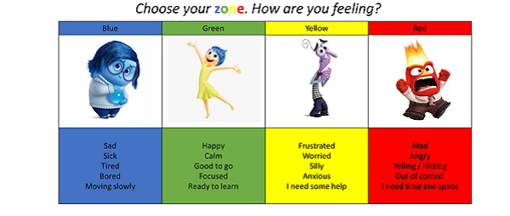
*I have started today
feeling (tick your answer):

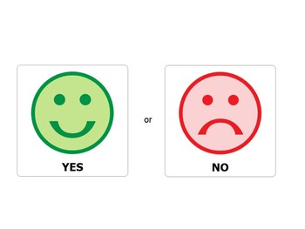

*I feel safe *I need to speak to
someone about how I feel:

*My weekend has been mostly (tick your answer):

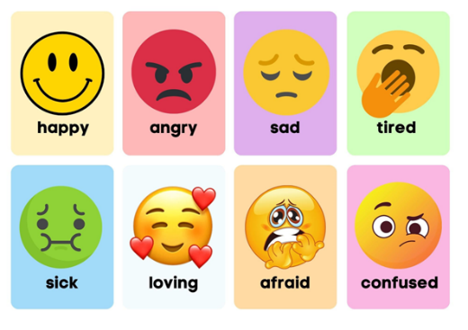
Want to tell us more about this?
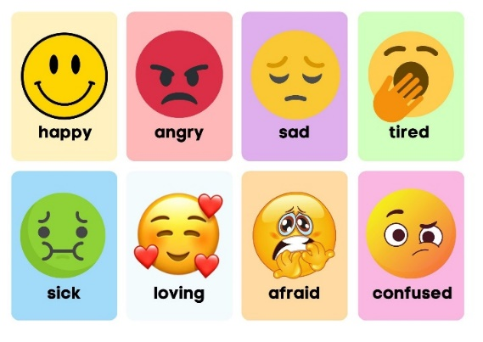
My feelings about the week ahead are mostly (tick your answer):
Want to tell us more about this?

*This week I am looking forward to……………………………………………………………

